1. Create a 1D array with elements from 1 to 10.

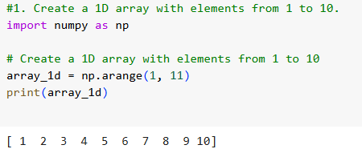

1. Create a 2D array of size 3x3 filled with zeros.

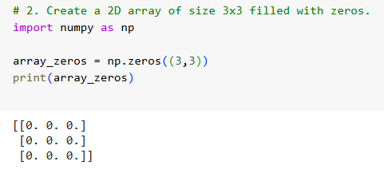

1. Find the maximum and minimum values in an array

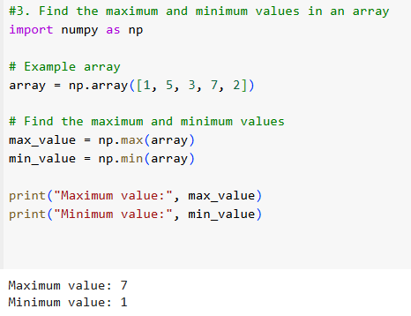

. 4. Reshape a 1D array into a 2D array of shape 2x5.

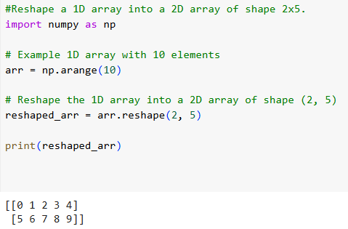

1. Generate a 1D array of 5 random integers between 10 and 50.

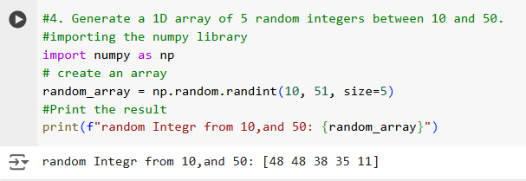

1. Convert the below list into numpy array then display the array Input: my_list = [1, 2, 3, 4, 5]

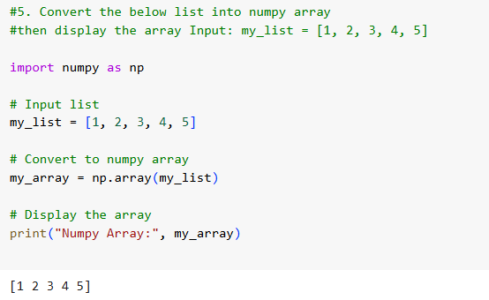

1. Convert the below list into a numpy array then display the array then display the first and last index and then multiply each element by 2 and display the result. Input: my_list = [1, 2, 3, 4, 5]

